***File sharing: layout explanation***

***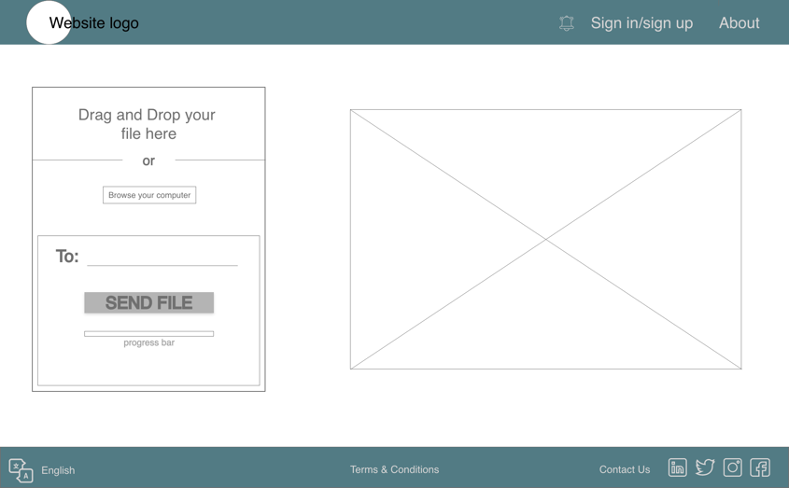****Logo*

Will be present at the top of every page to make sure the user is aware of the service

*About*

Will be present at the top of every page for the user to get to know the members and the project’s features.

*Drag and drop*

Allows the user to drag a file to the section and once dropped, will be selected to download.

*Browse your computer*

Allows users to search in their machine for the specific file they want to share.

*To:*

The username (email) of the user the file is meant to be send to, making only possible to share it between users of the platform.

*Send file*

The button is easily accessible and visible to users. It will send a link through email that will redirected to the receivers my downloads page.

*Progress bar*

To let the user know how long until the file is sent.

*Video*

Short video to show new users how easy it is to use and to make them feel more comfortable when it for the first time, while informing them of the features.

*Translator*

Easy access button that enables non-English users to use the app without languages barriers.

*Contact us*

Will allow the user to be in contact with one of the team members if any errors occur through a modal form on the right side of the screen.

*Social media*

Its positions next to the contact us button as one of the ways users can contact the team and be aware of the team’s progress and projects.

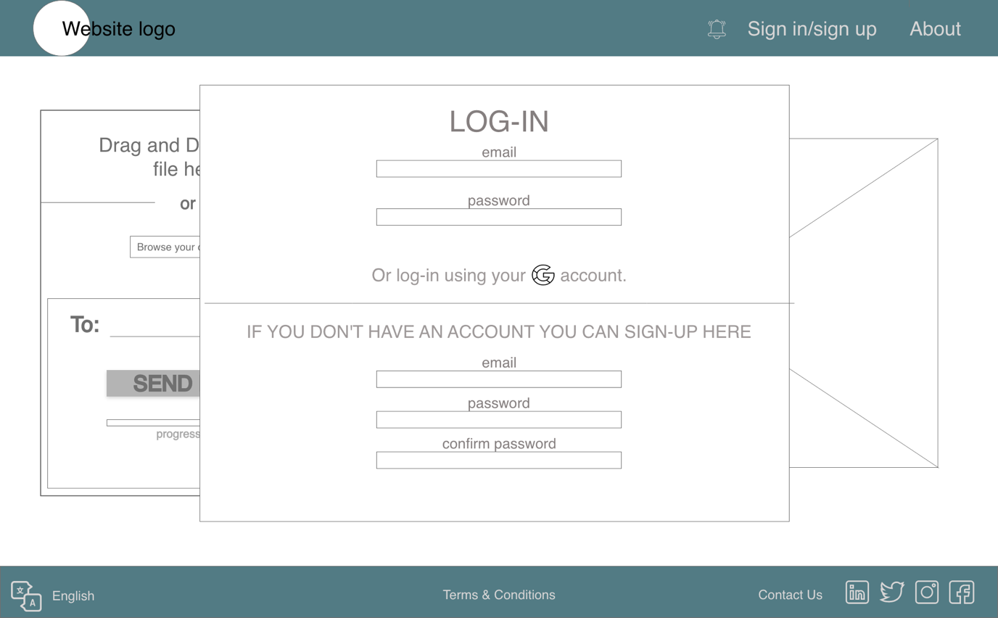

*Log-in/sign-in*

To be able to share a file the user needs to be signed in, either through their account or google. If they don’t have an account, it is possible to create one by simply introducing the email and the password. This button is situated in a generic place where most log-in/sign-in buttons are, making it easy for a new user to register.

*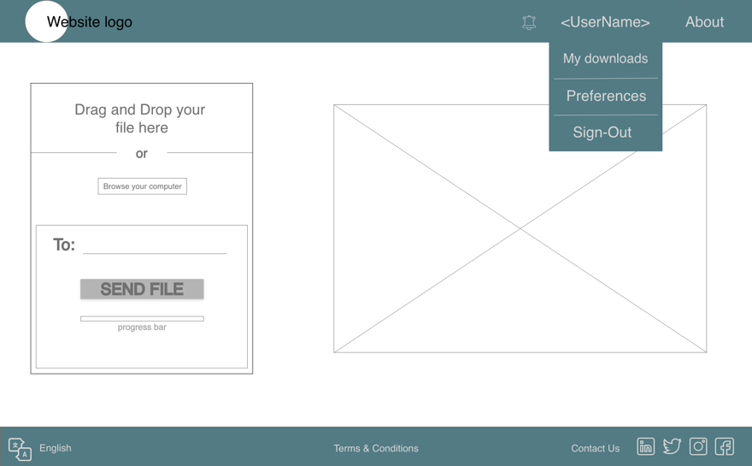 Username*

Sign-in/ log-in is changed to the user’s username after they have logged in, allowing the user to access their downloads list, preferences and to sign out of the session.

*Notification bell*

Situated in a visible and in a place the user is used to see it. It notifies the users if someone shared a file with them. The notification appears once they receive the email with the download link.

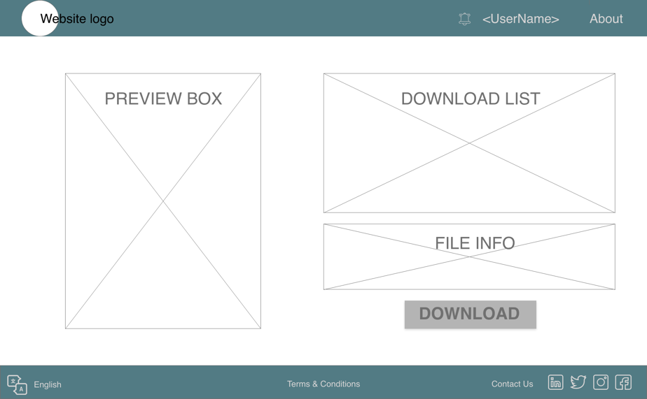

*Preview box*

The user can preview the files available before downloading. With this feature the user is sure about the file they are downloading. This is important specially because after downloading the file is deleted.

*Download list*

List of available downloads helps the users keep track of the files that have been shared with them without having to go to their email and search for the link.

*File info*

When a file is selected, the file info box gives information to the users about the type of file it is, its size, when it was uploaded (date and time) and the remaining time until deletion (3 days).

*Download button*

Will download the file to the user computer. The file will be set to download into the downloads/transfers folder; however, the user can change the destination.

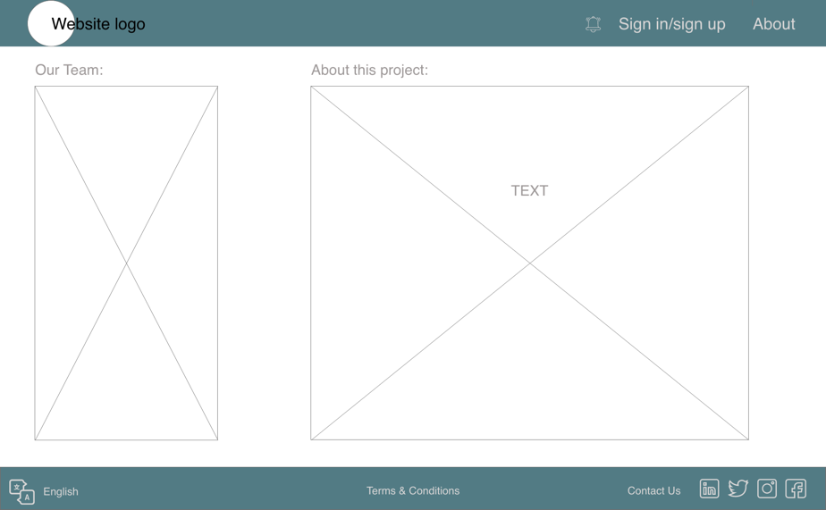

*Our team*

In the about page, the team is introduced to the user. This gives a sense of familiarity to them when using the platform. this section will have both the team members picture and their name.

*About the project*

Gives a brief idea how the file sharing works and also lists the features included in the project.

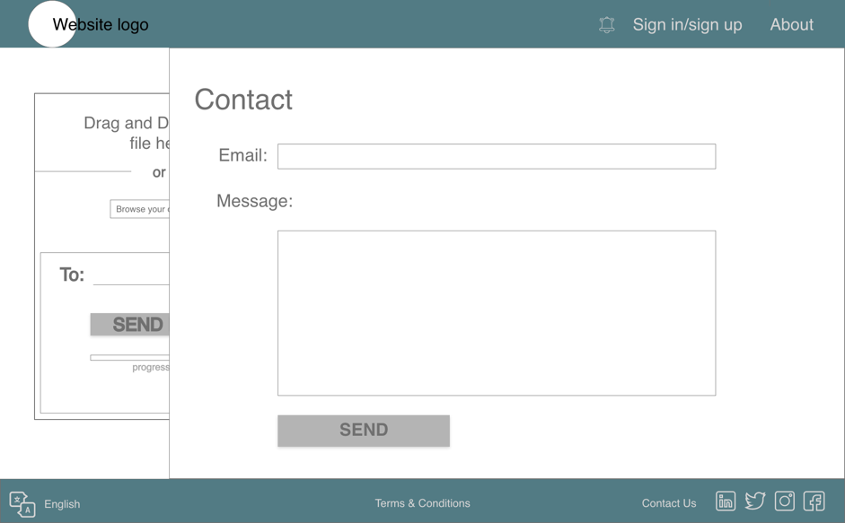

*Email:*

Boxes section for the user to introduce their email address if they need to contact the team.

*Message*

Where the user can right their message to the members of the project. This section provides a lot of space, so that the user’s message is not restricted to the size of the box. If the message is bigger than the size of the box, a scroll bar will appear.